LINUX PACKAGE MANAGEMENT

============================

**RPM**

----

The RPM Package Manager (RPM) is a powerful package management system used by Red Hat Linux and its derivatives such as CentOS and Fedora.

RPM also refers to the rpm command and .rpm file format.

An RPM Package consists of an archive of files and metadata including information such as dependencies and install location.

Package syntex

====================

**Package Name-version-Release.Architecture.Extention**

RHEL/OEL-9

acl-2.2.53-1.el9.x86_64.rpm

RHEL/OEL-8

acl-2.2.53-1.el8.x86_64.rpm

RHEL/OEL-7

acl-2.2.53-1.el7.x86_64.rpm

RHEL/OEL-6

acl-2.2.51-1.el6.x86_64.rpm - 64 bit

acl-2.2.51-1.el6.i386.rpm - 32 bit

First how we want to see where the packages are located and its location

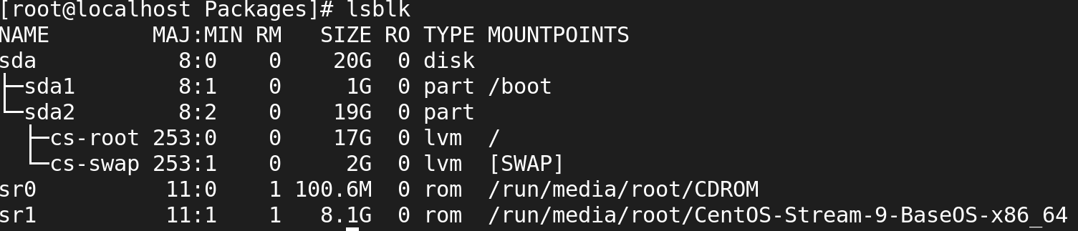

To enter into the Packages directory to view all the packages to be installted

**# cd /run/media/root/CentOS-Stream-9-BaseOS-x86_64/AppStream/Packages**

* The above path will take you to the Packages where all package files are stored

**[root@server Packages]**

* To list out the packages use **ls**.

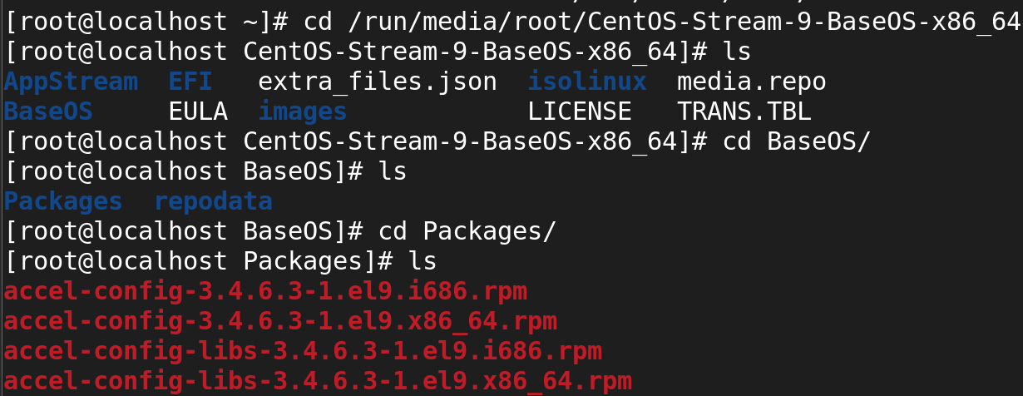

**Step 1.**

To install the packages using **rpm** tool **[use with .rpm extention]**

**# rpm -ivh zsh-5.8-9.el9.x86_64.rpm**

-I : install a package

-v : verbose

-h : print hash marks as the package archive is unpacked

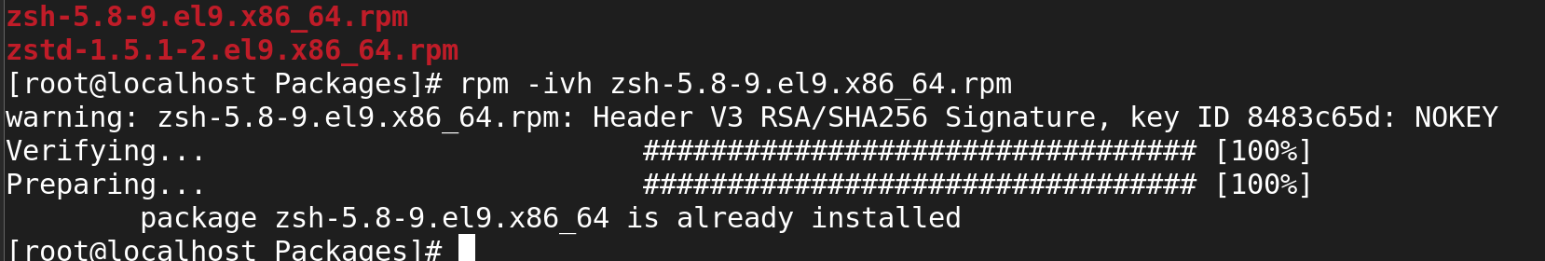

**Step 2.**

To view the installted packages

How to List All Installed RPM Packages

#rpm -qa

#rpm -qa httpd wget

rpm -q httpd

rpm -qa

rpm -qa|grep httpd



rpm -qa|wc -l

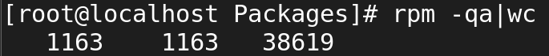

rpmquery httpd

rpmquery -a

rpmquery -a|grep net-tools

**# rpm -q zsh-5.8-9.el9.x86_64.rpm**

-q query operation

-a queries all installed packages



**Step 3.**

To remove the package instalted **[use without .rpm extention to remove]**

**# rpm -evh zsh-5.8-9.el9.x86_64**

**While removing the pakages we should remove the .rpm**

* -e erase operation

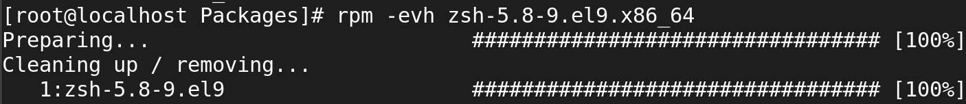

**Commands:**

rpm -ivh 🡺To install

rpm-erh 🡺To Remove

rpm -qa zip 🡺To view zipfiles

rpm -qa yum 🡺To filter norch

rpm -qa xz 🡺To filter xz

Is -l| wc - l 🡺To view Total line

ls -l| wc - w 🡺 words Count

ls -l| wc – c 🡺 Total character

rpm -ql 🡺 To list all files

rpm -qi zip 🡺 To view all information from rpm packages

To check dependencies of RPM Package before Installing

**# rpm -qpR createrepo_c-0.11.0-1.el8.x86_64.rpm**

-q : Query a package

-p : List capabilities this package provides.

-R: List capabilities on which this package depends

How to check dependencies of RPM Package before Installing

**# rpm -qpR createrepo_c-0.11.0-1.el8.x86_64.rpm**

-q : Query a package

-p : List capabilities this package provides.

-R: List capabilities on which this package depends..

**How to Query a file that belongs which RPM Package**



How to Query a Information of Installed RPM Package

=====================================================

**rpm -qi zsh-5.8-9.el9.x86_64**

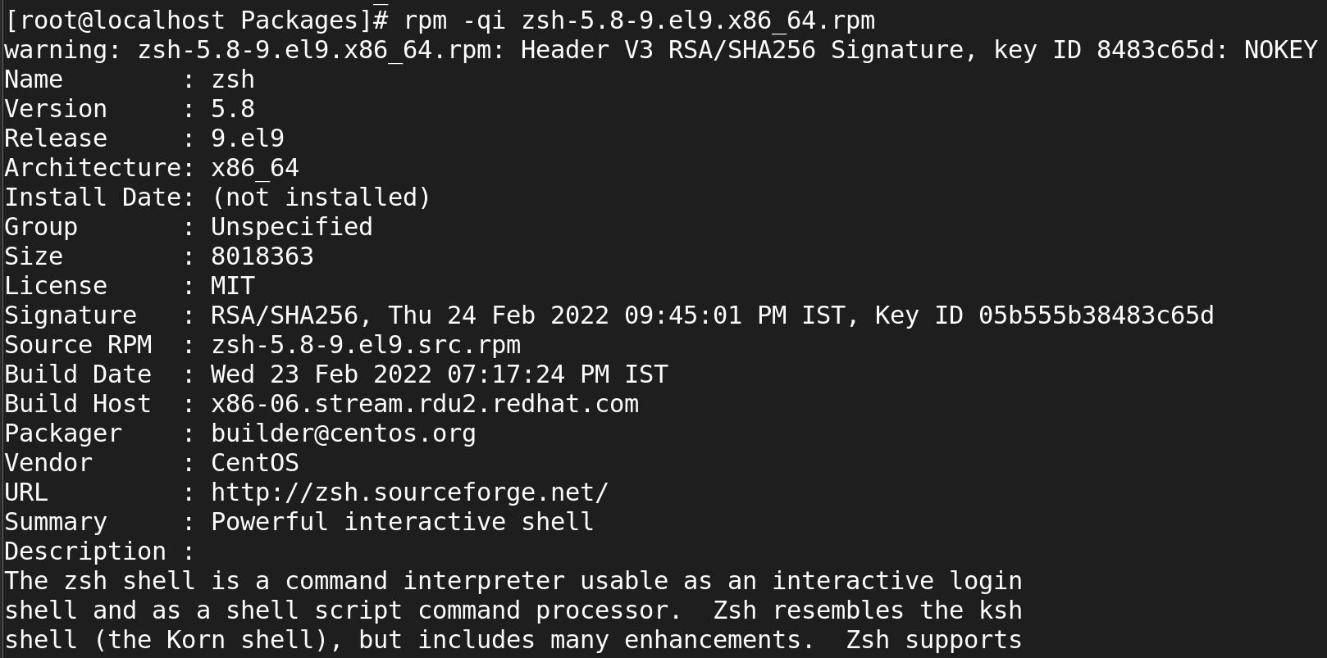

**How to check dependencies of RPM Package before Installing**

**# rpm -qpR createrepo_c-0.11.0-1.el8.x86_64.rpm**

